**Assignment 32.2**

**Problem Statement:**

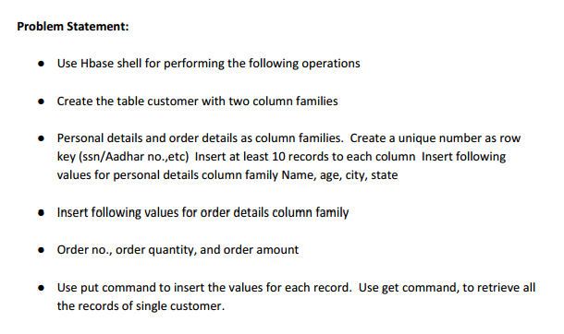

**Output:**

Creating table ‘customer’ using **‘create’** command.

The table ‘customer’ has two column families as:

* Personal details and
* Order details

The syntax for creating table with column families is as below:

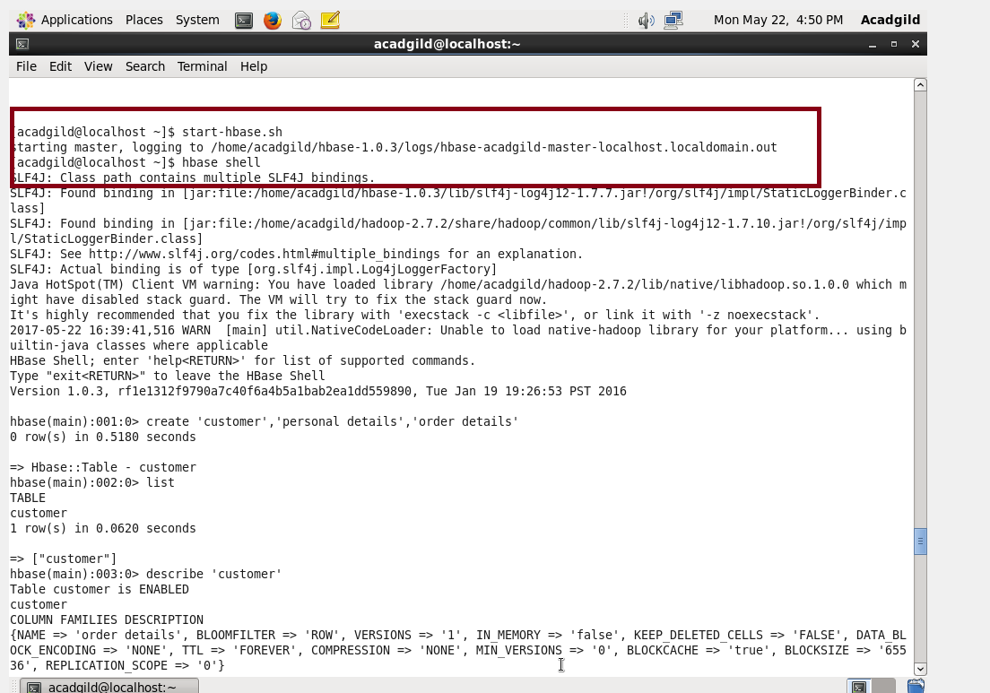

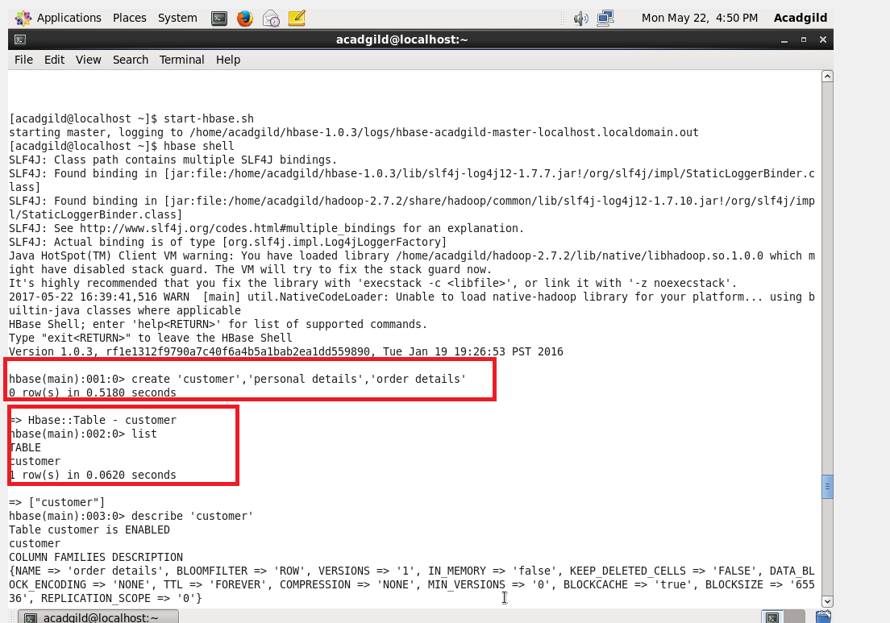

Inserting values for ‘Personal details’ column family and for ‘Order details’ column family of table ‘customer’ using ‘**put’** command.

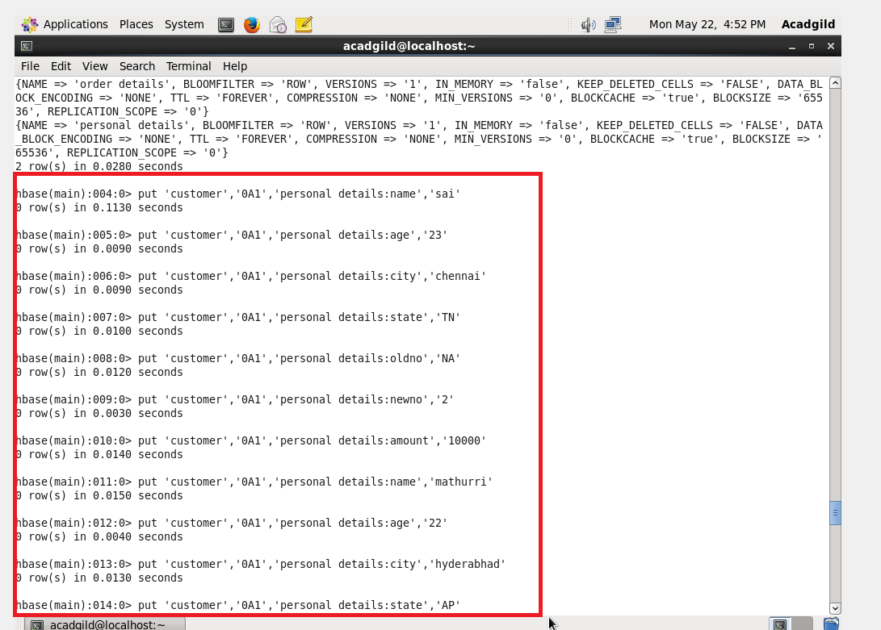

Retrieving all the records for customer using **‘get’** command.We retrieve the data using **row key** which is unique key for every record.

We can also retrieve only specific column family data or specific column data from particular column family.

The syntax is as mentioned below:

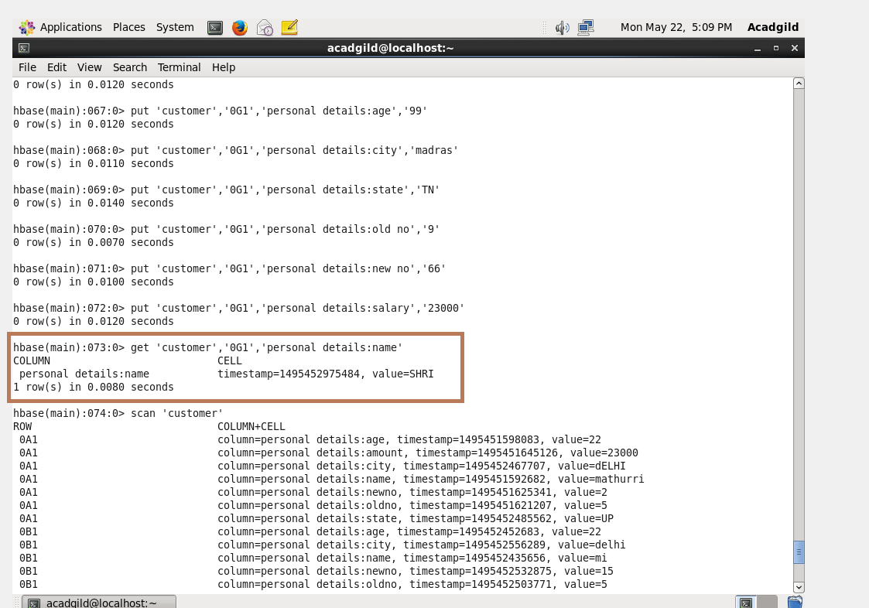

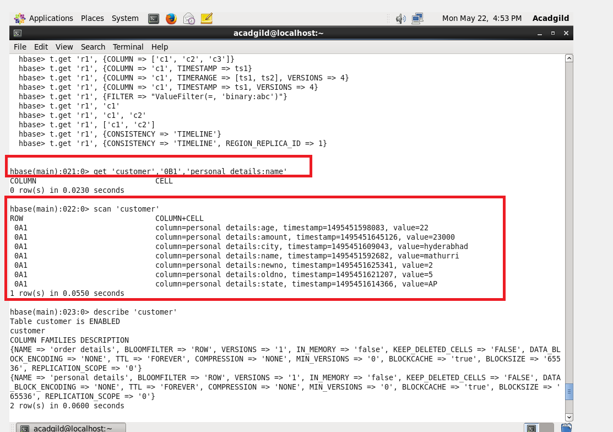

Using **‘scan’** command we can retrieve all the records of table ‘customer’ as below:

